**DEPARTMENT OF INFORMATION SCIENCE & ENGINEERING**



***Project Based Learning Report on***

**PARKING MANAGEMENT APP FOR ANDROID**

**BACHELOR OF ENGINEERING**

**in**

**INFORMATION SCIENCE AND ENGINEERING**

**by**

|  |  |
| --- | --- |
| ****Name**** | ****USN**** |
| **Mr. PRAJWAL R** | **1BY18IS084** |
| **Mr. PRASHANTH R** | **1BY18IS089** |
| **Mr. RAGHAVENDRA K M** | **1BY18IS093** |
| **Ms. SUGANDHA SINHA** | **1BY18IS119** |

*Under the Guidance of*

Prof. S Mahalakshmi

Assistant Professor



**BMS INSTITUTE OF TECHNOLOGY& MANAGEMENT**

BENGALURU-560064

2020-21

**ABSTRACT**

It is very common waiting outside a parking lot and looking if any space available in there, this overtime will be irritating and time consuming especially in traffic rich cities like Bangalore, Delhi etc.

Everyone would have frequently experienced that they park their vehicle somewhere beside the road and by the time they return the vehicle is gone, this would have been the worst day for a person having plans for the day. Thus, knowing the availability of parking space in advance would help people to plan for the same and save the time which would have been spent in looking for a spot in the lot. The parking fee is also a major concern of people, wherein many of them would not know the cost of parking per hour basis and which would cause them to pay more than the actual fee for it.

This Parking Management App is a parking solution which to solve the above problems by providing the user with the available space in the lot and calculate the amount accurately with the parameters of entry time and exit time. It will also keep history of all the vehicles parked at any parking spot with specific date and time.

(i)

**TABLE OF CONTENTS**

|  |  |  |
| --- | --- | --- |
| **CHAPTER** | **TOPIC** | **Pg. No.** |
| 1 | Introduction   * 1. Introduction   2. Motivation   3. Objectives | 1-2 |
| 2 | Background   * 1. Introduction   2. Algorithm   3. Design/Methods   4. Results/Discussion   5. Applications | 3-12 |
| 3 | 3.1 Conclusion  3.2 Future Enhancements  3.3 References | 13-14 |

(iii)

**List of Figures/Tables**

|  |  |  |
| --- | --- | --- |
| **Figure No.** | **Name of Figures** | **Page No.** |
| 2.2.1 | Algorithm | 4 |
| 2.3.1 | Flow of the Activities in Application | 6 |
| 2.3.2 | The design of Application | 7 |
| 2.4.1 | Home Activity | 9 |
| 2.4.2 | Admin Home Activity | 9 |
| 2.4.3 | Login Activity | 9 |
| 2.4.4 | Register Activity | 9 |
| 2.4.5 | Available Slots Activity | 10 |
| 2.4.6 | Parked Vehicles Activity | 10 |
| 2.4.7 | Parked History Activity | 10 |
| 2.4.8 | Add Vehicle Activity | 10 |
| 2.4.9 | Remove Vehicle Alert Dialog | 11 |
| 2.4.10 | Vehicle Exit Activity | 11 |
| 2.4.11 | Add Vehicle Alert Dialog | 11 |
| 2.4.12 | Forgot Password Alert Dialog | 11 |

**CHAPTER-1**

**INTRODUCTION**

**1.1 INRODUCTION**

With the increase in use of private vehicle in recent years, the problem of car parking has raised in busy and big cities of the world. In crowded cities of the world, mostly a person must spend a lot of time in finding the vacant parking lot.

As an important component of traffic system, parking management system is playing an important role and affecting people’s daily life. By detecting and processing the information from parking lots, smart parking systems allows driver to obtain real-time parking information and alleviates parking contentions.

A Smart Parking Management system is a parking solution which is embedded into parking spots to detect whether parking bays are free or occupied through real-time data collection. It will not only help in generating bill for parking of car but will also keep record of all the vehicles parked at any parking spot with specific date and time.

**1.2 MOTIVATION**

1. Optimized parking – Users find the best spot available, saving time, resources and effort. The parking lot fills up efficiently and space can be utilized properly by commercial and corporate entities.

2. Reduced traffic – Traffic flow increases as fewer cars are required to drive around in search of an open parking space.

3. Reduced pollution – Searching for parking burns around one million barrels of oil a day. An optimal parking solution will significantly decrease driving time, thus lowering the amount of daily vehicle emissions and ultimately reducing the global environmental footprint.

4. Enhanced User Experience – A smart parking solution will integrate the entire user experience into a unified action. Driver’s payment, spot identification, location search and time notifications all seamlessly become part of the destination arrival process.

5. Increased Safety – Parking lot employees and security guards contain real-time lot data that can help prevent parking violations and suspicious activity. License plate recognition cameras can gather pertinent footage. Also, decreased spot-searching traffic on the streets can reduce accidents caused by the distraction of searching for parking.

**1.3 OBJECTIVES**

* To develop an intelligent, user friendly automated car parking system which reduces the manpower and traffic congestion.
* To improve the performance and satisfy the need of free parking lot.
* To reduces the time wastage in finding the vacant parking lot.

**CHAPTER-2**

**BACKGROUND**

**2.2 ALGORITHM**

*Fig. 2.2.1 Algorithm*

**Step 1:** The HomeActivity will be the first activity triggered on opening of app, here there will be two options i.e., the users can view the parking spaces and the admin can login.

**Step 2:** If it is user then the control flows to AvailableSlotsActivity where the details of all the parking slots i.e., the name of the slot, location, available and total slots will be displayed in a list view.

**Step 3:** If the admin has already registered, they click on login then the LoginActivity will be invoked where they will have to provide their credentials to login, else the admin can register by clicking on register.

**Step 4**: After login, the admin will be displayed with the AdminHomeActivity where the details of the admin will be displayed, and he will be given an option to enter vehicle or view history.

**Step 5:** If the admin clicks on parked vehicles, he will be directed to ParkedvehicleActivity where the vehicles present in the lot will be displayed in a list view and he will be given an option to enter a vehicle, after entering vehicle, the details are validated with help of regular expression and saved to the database.

**Step 6:** If the admin clicks on a list containing a vehicle present in the lot, then the control flows to BillActivity where the amount will be calculated and displayed to the admin.

**Step 7:** If the admin clicks on history, he will be directed to ParkedHistoryActivity where the details of previously parked vehicles will be displayed in a list view.

**2.3 SYSTEM DESIGN**

**2.3.1 APPLICATION COMPONENTS OF PROJECT**

Application components are Core Building Blocks of an Android Application. It is an entry Point for System or Users from which they can enter in App.



The project consists of the following components:

1. **Activities:**

An activity represents a single screen with a user interface, in-short Activity performs actions on the screen. If an application has more than one activity, then one of them should be marked as the activity that is presented when the application is launched, which is done in the manifest file.

The project has 9 activities, starting from “HomeActivity”, which is the first screen visible to the users once they open the app, the clicks on the views will lead to trigger of respective activities, the flow is represented below:

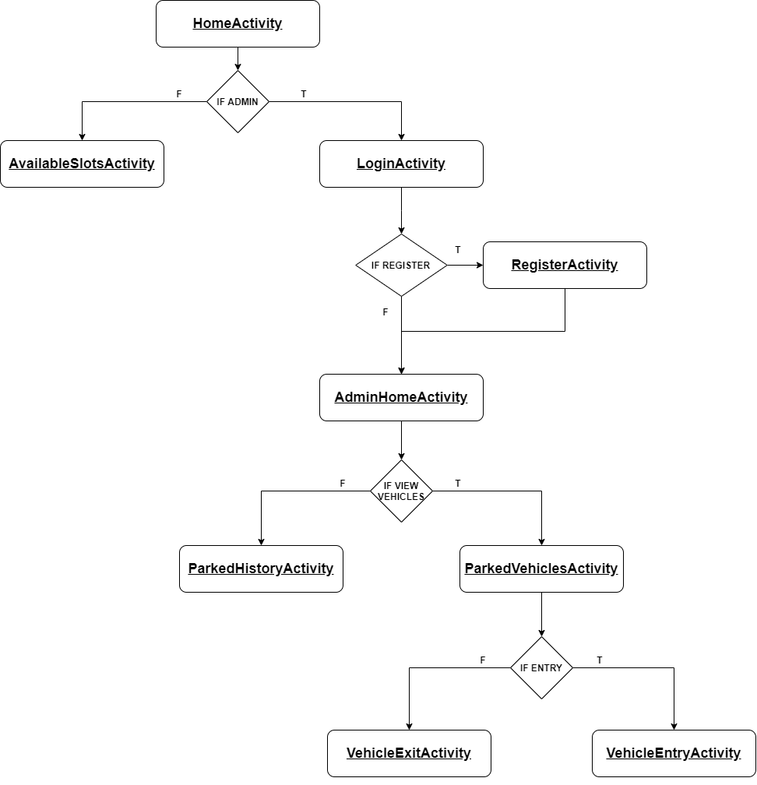

Figure 2.3.1: Flow of the Activities in Application

1. **Views:**

View is the basic building block of UI (User Interface) in android. View refers to the android. view. View class, which is the super class for all the GUI components.

The app contains Text View, Image View, Button, Edit Text, List View, Progress Bar, Card View which helps in achieving the flow of Activities and design the layout responsively.

Text Views are used to display the field labels and the details of the Admin. Edit Texts are used to take the details during login, register and vehicle entry. Image Views are used to display the icon of the app and List Views are used to display the slots for the users with details of number of available slots, area, name and display the admin list of parked vehicles and list of vehicles visited.

1. **Layouts:**

Android Layout is used to define the user interface that holds the UI controls or widgets that will appear on the screen of an android application or activity screen.

The app is designed using Constraint Layout, Linear Layout, Swipe Refresh layout.

Swipe Refresh layout is used in AvailableSlotsActivity for users, ParkedVehicleActivity and ParkedHistoryActivity for admin to retrieve the latest information from the database.

1. **Intents, Resources:**

The app communicates or transfers the control and information from one Activity to other Activity with the help of intents.

The ID’s, String values, Colors, Styles, XML file for every Activity, Drawable such as icons are stored in resource folder.

**2.3.2 USER INTERFACE DESIGN**

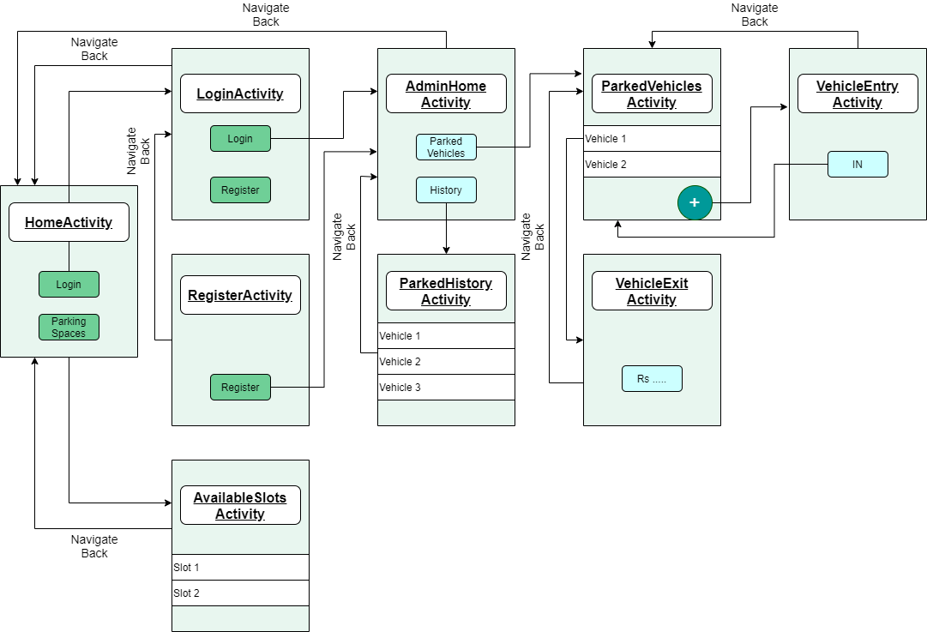

Figure 1.3.2: The design of Application

The user interface (UI) for an Android app is built as a hierarchy of layouts and widgets. The layouts are View Group objects, containers that control how their child views are positioned on the screen. Widgets are View objects, UI components such as buttons and text boxes.

The Application is designed using the components of android such as, Layouts, Buttons, Text Views, Edit Texts, Card Layouts etc.

The above figure gives a brief design of the application and its flow. The app is designed using Constraint Layout which is a View Group containing many Views such as Edit Texts, Buttons etc.

The Constraint Layout gives the option of constraining the views with respect to the parent i.e., View Group or other Views in the layout.

The List View is designed using a Recycler View, which is been loaded with data with the help of adapters which acts as a bridge between the View and the underlying data.

These are used in AvailableSlotsActivity, ParkedVehicleActivity, ParkedHistoryActivity.

**2.4 RESULTS**

The app has 2 types of Users,

1) Normal User

2) Admin User

Normal User:

* User login or registration is not required by the user
* These types of users can checkout the parking areas using the *Parking Spaces* button
* In addition to this, also able to view the currently available number of parking slots in a particular parking area
* The data will get updated dynamically as soon as the Admin User updates the data in his app.

Admin User:

* User login or registration is required by the user
* These types of user have the accessibility to modify the data in the app regarding his/her Parking area.
* Admin can update vehicles in the database whenever he/she sees a vehicle entering/exiting the parking area.
* The app can automatically generate the bill according to the parking duration.

**2.5 PROJECT APPLICATIONS**

* This project can be implemented in shopping malls, public parking areas to monitor parking.
* Automation and increased efficiency and transparency of parking charges.
* General public can check the slots available for parking.
* Helps to attain efficient parking system.

**CHAPTER-3**

3.1 CONCLUSION

1. The parking management system app is effective in detecting the available parking slots through real-time data collection.
2. In addition to that the app can be a part of a bigger revolution by reducing the traffic in a city by informing the user about the parking spaces.
3. The manual process of entering the vehicles in the vehicle register book is eliminated.
4. Further enhancement is required to make the user view his or her nearby parking areas.
5. Overall system can handle all the requests from the User to give a fresh digital look for current parking management system

3.2 FUTURE ENHANCEMENTS

1. Online booking of parking slots in a parking space/area so that users can reserve the parking slot for his/her vehicle.
2. Redesigning the user interface of the app.
3. Creating a profile page for the admin of the parking space so that he/she can update not just his/her profile but also details regarding the parking space/area.
4. Integrating the app with Google maps to easily locate or navigate to the parking area.
5. A feature to view the nearby parking areas

3.3. REFERENCES

[1]. M. Owayjan, B. Sleem, E. Saad and A. Maroun, "Parking management system using mobile application," 2017 Sensors Networks Smart and Emerging Technologies (SENSET), 2017, pp. 1-4, doi: 10.1109/SENSET.2017.8125048.

[2]. C. Ng, S. Cheong, E. Hajimohammadhosseinmemar and W. Yap, "Mobile outdoor parking space detection application," 2017 IEEE 8th Control and System Graduate Research Colloquium (ICSGRC), 2017, pp. 81-86, doi: 10.1109/ICSGRC.2017.8070573.

[3]. B. K. Patil, A. Deshpande, S. Suryavanshi, R. Magdum and B. Manjunath, "Smart Parking System for Cars," 2018 International Conference on Recent Innovations in Electrical, Electronics & Communication Engineering (ICRIEECE), 2018, pp. 1118-1121, doi: 10.1109/ICRIEECE44171.2018.9008662.